### **How can you make a cone with analytical geometry? Or Pretty Cone Trees!**

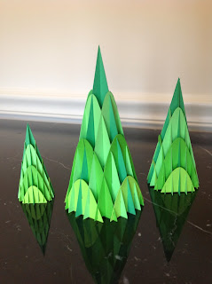

Cone Sliceform from derived equation

My husband wrote this blog post with the mathematical analysis and now I am updating it with the PDF's and .Studio files. Let me explain...my husband is taking an analytical geometry course and he gave me the graphs to create this cone. I think he did a fabulous job!

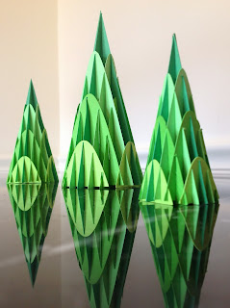

I love the reflection of the trees in the glossy surface.

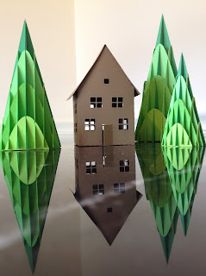

I think the cones look terrific as trees with my paper house from a previous post. <http://papercraftetc.blogspot.com/2013/09/i-love-making-houses.html> Don't you agree?

Using the distance formula r^2 = sqrt(x^2+y^2) and the formula for the line in x-z space z=h/a(x) and knowing that the radius r must equal the x value in x-z space, you combine both equations. This gives you the equation for the surface z = h/a(sqrt(x^2+y^2). You can change the height to radius using the parameters h and a.

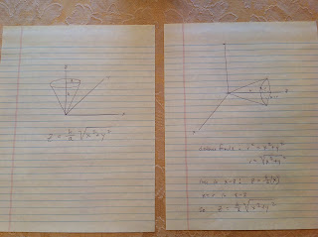

To create the sliceform, you need three slices in each direction. Using the golden ratio height/base = 1.6, so height/radius = 3.2. Next, find equations for each slice in z-y space by setting x. For a six inch height, radius = 6/3.2 = 1.875. Divide this into four increments of 0.469 inches each to set x. This gives these four equations in z-y space:

For x=0: z=3.2sqrt(y^2)

For x=0.469: z=3.2sqrt(0.469^2+y^2)

For x=0.938: z=3.2sqrt(0.938^2+y^2)

For x=1.406: z=3.2sqrt(1.406^2+y^2)

The PDF and .Studio files were created for just one of the trees. The files will need to be resized if you would like to create a forest of trees like I did in the pictures above.